# Unit Tests for Caliber/MT Connector

## VENDORS

**Caliber to MT**

*A1: Check vendor details sync and subsidiary (client) association*

1. Create a vendor in Caliber. Fill out the following fields in the General Information tab: Address 1, Address 2, City, State, Zip Code, and Country. In the Accounting tab, select a Payment Term.
2. Assign the vendor to two (2) clients.
3. Wait for Caliber -> MT sync to complete.
4. Check that the vendor was created in MT. In the Vendor Details section, check that Address fields mapped correctly. In Invoice Preferences section, check that the Payment Term selected in Step 1 maps to Terms field.
5. In the Vendor Details section, check the Subsidiary field. It should be populated with one of the client selections you made in Step 2.
6. Click the Subsidiary field dropdown. It should contain 2 options corresponding to the 2 clients you selected in Step 2.

*A2: Check vendor update*

1. In Caliber, update Address 1 field for vendor created in Test A1 (General Information tab).
2. Uncheck both clients assigned in Test A1.
3. Assign the vendor to 2 new clients.
4. Change Payment Terms (Accounting tab).
5. Wait for Caliber -> MT sync to complete.
6. Check that the Address 1 field has updated in MT correctly.
7. Check that the Subsidiary field contains the 2 new clients selected in Step 3.
8. Check that the Terms field has updated in MT correctly.

**MT to Caliber**

*B1: Check vendor update*

1. In MT, update Address 1 field for vendor created in Test A1.
2. Update Terms field for vendor created in Test A1.
3. Wait for MT -> Caliber sync to complete.
4. Check that the Address 1 field has updated in Caliber correctly.
5. Check that Payment Terms field has updated in Caliber correctly.

## INVOICES

**Caliber to MT**

*C1: Check invoice data sync*

1. In Caliber, create an invoice with the following data:

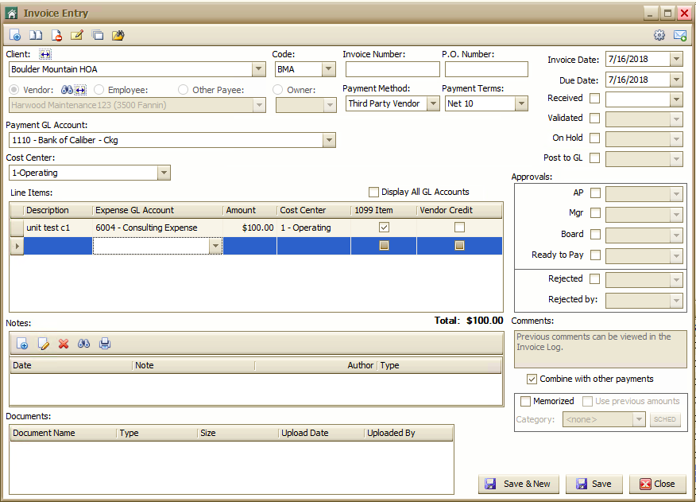

1. Wait for Caliber -> MT sync to complete.
2. Check that the invoice has been created in MT (should appear in the Invoices tab).
3. Check that the following fields have mapped correctly:

|  |  |
| --- | --- |
| **Caliber** | **MT** |
| Vendor | Vendor Name |
| Payment Terms | Terms |
| Invoice Date | Invoice Date |
| Due Date | Due Date |
| Cost Center (on header section) | Class (header level) |
| Description (line item) | Description (expense level) |
| Expense GL Account (line item) | Account (expense level) |
| Amount (line item) | Amount (expense level) |
| Cost Center (line item) | Class (expense level) |

*C2: Check invoice data update*

1. Update invoice amount, line item Cost Center, and Payment Terms on invoice created in Test C1. Save.
2. Wait for Caliber -> MT sync to complete.
3. Check that the updates made in Step 1 are reflected in the MT invoice from Test C1.

**MT to Caliber**

*D1: Check invoice sync to Caliber after posting from MT*

1. In MT, create an invoice with the following data:
2. Post the invoice to Caliber.
3. Wait for MT -> Caliber sync to complete.
4. Check that an invoice has been created in Caliber and the data have mapped correctly.

## PAYMENTS

**Caliber to MT**

*E1: Check payment sync for payments made in Caliber*

1. For invoice created in Test C1, make a payment in Caliber for the full invoice amount.
2. Wait for Caliber -> MT sync to complete.
3. Test C1 invoice should no longer appear in Invoices tab (unpaid invoices). Check the Payments tab and ensure you can see the payment in this tab. Click on the payment amount-- The Payment Details screen | Status section should show “Paid. Payment was made in accounting software.”

**MT to Caliber**

*F1: Check payment sync for payments made in MT*

1. For invoice created in Test D1, make a Manual Check payment in MT for the full invoice amount.
2. Provide a check number and Mark as Paid.
3. Wait for MT to Caliber sync to complete.
4. Check that invoice has ‘paid’ status in Caliber and remaining balance is zero.

## GL ACCOUNTS

**Caliber to MT**

*G1: Check GL Account sync from Caliber to MT and subsidiary (client) association*

1. Go to Client Dashboard of any client in Caliber.
2. Open Chart of Accounts toolbox (right-click and select Chart of Accounts).
3. Add new GL Account called “Unit Test G1”
4. Assign a vendor to the Client selected in Step 1.
5. Note down a vendor that is NOT assigned to the client from Step 1.
6. Wait for Caliber -> MT sync to complete.
7. Begin manually creating a new invoice in MT (navigate to Inbox, click ‘create an invoice without a document’) and type in Vendor Name from Step 4.
8. On the expense line, click the ‘Account’ dropdown. The GL Account you created in Step 3 should appear in the dropdown.
9. On the same form, delete the current vendor name and type in Vendor Name from Step 5.
10. On the expense line, click the ‘Account’ dropdown. The GL Account you created in Step 3 should NOT appear in the dropdown.

*G2: Check GL Account update from Caliber to MT*

1. Update GL Account name of GL Account created in Test G1 Step 3.
2. Wait for Caliber -> MT sync to complete.
3. Begin manually creating a new invoice in MT (navigate to Inbox, click ‘create an invoice without a document’) and type in Vendor Name from Test G1 Step 4.
4. On the expense line, click the ‘Account’ dropdown. The updated GL Account name you set in Step 1 should appear in the dropdown. The old GL Account name (from Test G1 Step 3) should NOT appear in the dropdown.

## CLASSES (COST CENTERS)

**Caliber to MT**

*H1: Check Cost Center Sync from Caliber to MT and subsidiary (client) association*

1. Go to Client Dashboard of any client in Caliber.
2. Open Cost Centers toolbox (right-click and select Cost Centers).
3. Add new Cost Center called “Unit Test H1”
4. Assign a vendor to the Client selected in Step 1.
5. Note down a vendor that is NOT assigned to the client from Step 1.
6. Wait for Caliber -> MT sync to complete.
7. Begin manually creating a new invoice in MT (navigate to Inbox, click ‘create an invoice without a document’) and type in Vendor Name from Step 4.
8. On the expense line, click the ‘Class’ dropdown. The Cost Center you created in Step 3 should appear in the dropdown.
9. On the same form, delete the current vendor name and type in Vendor Name from Step 5.
10. On the expense line, click the ‘Class’ dropdown. The Cost Center you created in Step 3 should NOT appear in the dropdown.

*H2: Check Cost Center update from Caliber to MT*

1. Update Cost Center name of GL Account created in Test G1 Step 3.
2. Wait for Caliber -> MT sync to complete.
3. Begin manually creating a new invoice in MT (navigate to Inbox, click ‘create an invoice without a document’) and type in Vendor Name from Test G1 Step 4.
4. On the expense line, click the ‘Class’ dropdown. The updated Cost Center name you set in Step 1 should appear in the dropdown. The old Cost Center name (from Test G1 Step 3) should NOT appear in the dropdown.